Data analysis notes

Day 1

Day 2

Data types

* Collecting data, we usually collect multiple measurements from one point of interest.
* Each person who responds to me is called an observation. They are the thing I am observing.
* Variables are measurements I take from the observations.
* The type of data what information we can find out from it, and how we can sue it for analysis
* Qualitative data is used for qualities or characteristics – collected through conversation, transcripts, dairies and surveys with open ended questions, narrative or disruptive language
  + Nominal data is descriptive, it labels data but has no order. No hierarchy.
  + Nominal data is used to see the most common
* Ordinal data is descriptive with an imposed order – abilities (beginner, intermediate, master). Qualification levels (GCSE, A level, Degree, Masters, PHD)
* ORDINAL data does not move in set intervals, the difference between satisfied and very satisfied might not be the same as the difference between satisfied and neither satisfied nor unsatisfied.
* Quantitative data relates to quantities, is spilt into discrete or continuous values
  + Discrete values are whole numbers, a football can score 3 goals not 3.7.
* Continuous values can be meaningfully divided down.
  + I am 162cm tall
  + I am 162.4cm tall
* I could continue splitting my height into more fractional, precise values so it is continuous.
* Measurements can be interval or ration data. The difference between 7 and 8 is the same difference between 11 and 12 (unlike ordinal data) ration data cannot fall below 0.
* Temperature in Celsius can go below 0 and often does. It is continuous interval data.
  + crime rate cannot go below 0
  + I cannot have -14 crime, it is continuous ration data
* 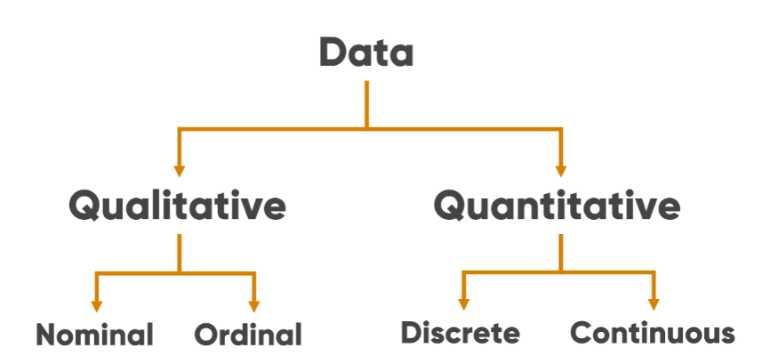Quantitative data can be measured in mathematical ways. Statistics like the mean, mode and median can be found out to give the data shape and find average values.
* Storing measurements,

Summary

* Data types help dictate what can or can’t be done with data
* Data is generally qualitative or quantitative
* Observations are the subject I am studying
* I will measure their variables which will different
* Measurements are generally stored in tables
* Rows are observations, columns are variables

Statistics

Relates to the collection, analysing, interpretation and visualization of data

Stats to see patterns and trends and to find significant values to a set

Descriptive statistics – summarise the data by finding the typical value, find a shape of the data, or explain how varied the data is. Help show the features of data allowing for work on patterns, trends and outliers.

Inferential statistics – help make predictions and draw conclusions. Found with more complex methods like regression and hypothesis testing.

Five figure summaries

Week 3 day 1

Selections

Being able to control actions taken or data requested based on a condition is fundamental.

the process of making a decision within a program based on the results of an event

if statements allow us to compare two or more bits of data and run code based on the outcome of the comparison.

“elif” else or if

Choices -

Double “==” comparison either side